Date
Project name | Library Management System
Team ID | SWTID-2026-1363
Maximam Marks
Ideation Phase
Empathize & Discover

Project Title:
Library Management System using ServiceNow

Empathy Map Canvas:
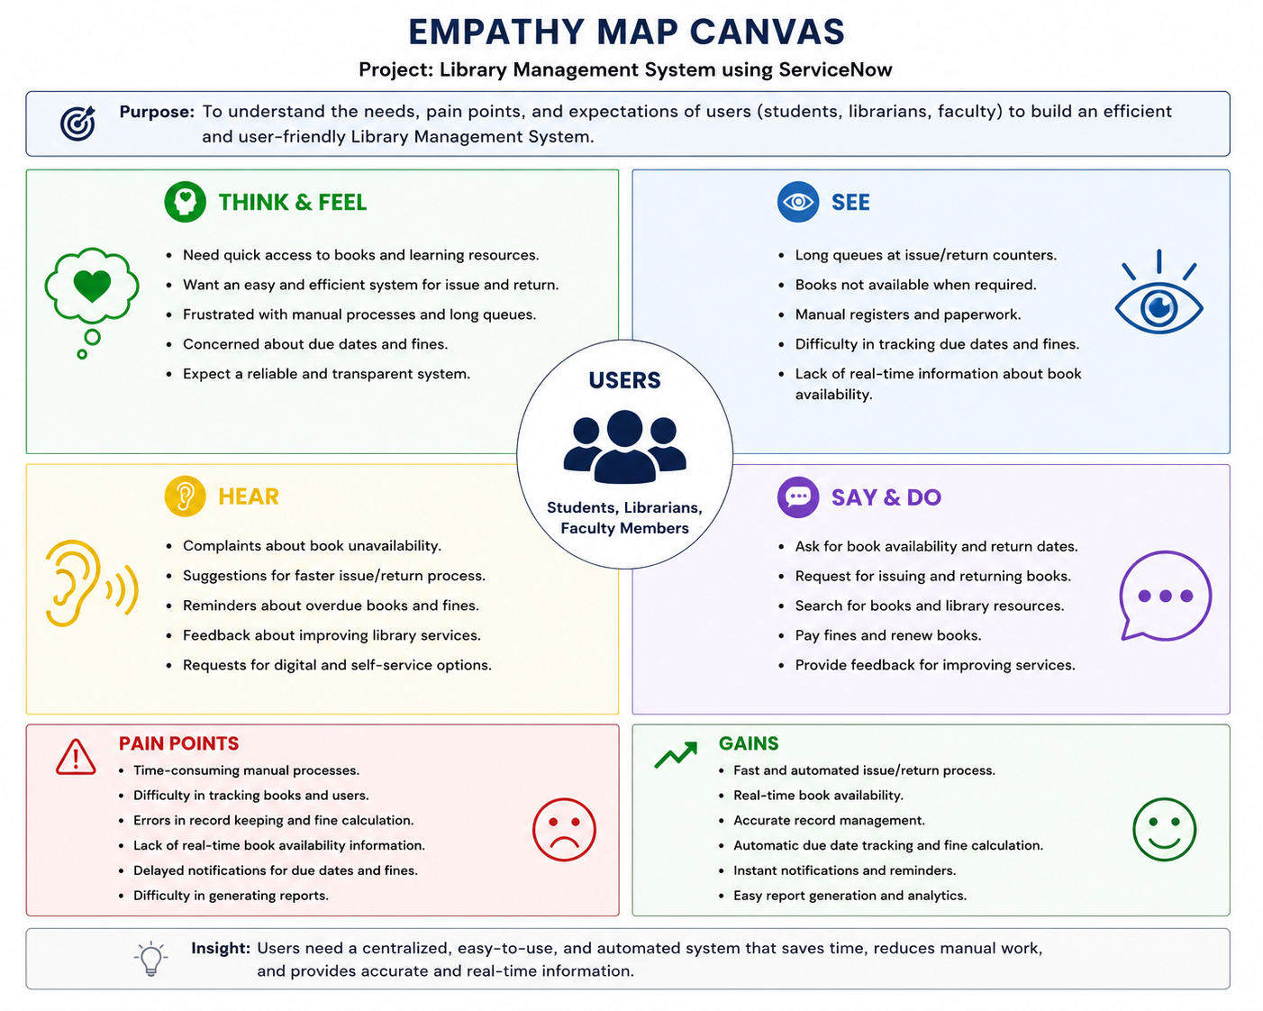

An Empathy Map Canvas isdhmen a collaborative tool used to build a deep, shared understanding of your users, their needs, and their pain points. For a project focused on access control and workflow automation, it maps the specific perspectives of the system's users—such as employees, system administrators, or external approvers.

